Project Documentation

COOKBOOK:YOUR VIRTUAL KITCHEN ASSISTANT

## Project Title :CookBook:Your virtual kitchen assistant

* + **Team ID :NM2025TMID47803**
  + **Team Leader:** Name : DEEPAK S

Mail id : sakthiveldeepak20@gmai.com

## Team Members:

1.Name : ADHITHYAN M

Mail id : adhiagam1@gmail.com

2. Name : ANISHRAJ K

Mail id : anish634708@gmail.com

**3.**Name : DHAMODHIRAN E

Mail id : elumalaidhamodhiran@gamil.com

# 1.Introduction

## 🍽️ **SD Yummy Foods – Discover, Learn, and Cook Delicious Dishes with Ease!**

👨‍🍳 **Welcome to SD Yummy Foods**, your go-to destination for learning how to prepare tasty and popular dishes from around the world! This easy-to-use recipe website is designed for everyone—from beginners in the kitchen to experienced home cooks. With clear instructions and helpful cooking tips, SD Yummy Foods makes it simple to bring mouthwatering meals to life in your own kitchen.

🍲 **Built with a focus on simplicity and user-friendliness**, SD Yummy Foods lets you explore recipes across a variety of categories including breakfast, lunch, dinner, snacks, and desserts. Each recipe includes a detailed list of ingredients, exact measurements, and step-by-step cooking procedures. Whether you're trying something new or perfecting a classic dish, you'll find all the support you need.

🌶️ **From savory main courses to sweet treats**, SD Yummy Foods brings a wide variety of recipes to your fingertips. Whether you're making a quick meal or preparing for a special occasion, you can browse through a growing collection of dishes that fit every taste and skill level. No matter what you're craving, you’ll find the perfect recipe right here.

🍛 **Each recipe is more than just a guide**—it's a complete cooking experience. Along with the basic steps, you’ll get practical tips like how to enhance flavor, how to avoid common mistakes, and how to present your dishes beautifully. These small insights make a big difference in helping you build confidence in your cooking.

📱 **Start your cooking adventure today with SD Yummy Foods**, and turn everyday ingredients into amazing meals. Whether you're cooking for yourself, your family, or guests, this platform is your trusted companion in the kitchen. Let SD Yummy Foods help you bring joy to your table—one recipe at a time. 🍴

# Project Overview

• **Purpose**:  
SD Yummy Foods is a recipe-sharing platform that helps users discover, learn, and cook a variety of delicious dishes. It allows users to browse, search, and follow step-by-step recipes, while also sharing their own creations with the community.

• **Features**:  
 Recipe listing with ingredients and preparation steps

1. User-submitted recipes with image upload support
2. User can subscribe and get instant update from our SD Yummy Foods
3. Admin dashboard to manage users, recipes, and site content

# Architecture

* + **Frontend:** React.js with Bootstrap and Material UI
  + **Backend:**[Not applicable-fronted-only simulation]
  + **Database/Storage:**LocalStorage(for persistence)

# Setup Instructions

## Prerequisites:

Here are the key prerequisites for developing a frontend application using React.js:

* **Node.js and npm**:

Node.js is a powerful JavaScript runtime environment that allows you to run JavaScript code on the local environment. It provides a scalable and efficient platform for building network applications.

Install Node.js and npm on your development machine, as they are required to run JavaScript on the server-side.

* Download: <https://nodejs.org/en/download/>
* Installation instructions: <https://nodejs.org/en/download/package-manager/>

* **React.js**:

React.js is a popular JavaScript library for building user interfaces. It enables developers to create interactive and reusable UI components, making it easier to build dynamic and responsive web applications.

Install React.js, a JavaScript library for building user interfaces.

* Create a new React app:

npx create-react-app my-react-app

Replace my-react-app with your preferred project name.

* Navigate to the project directory:

cd my-react-app

* Running the React App:

With the React app created, you can now start the development server and see your React application in action.

* Start the development server:

npm start

This command launches the development server, and you can access your React app at http://localhost:3000 in your web browser.

* **HTML, CSS, and JavaScript**: Basic knowledge of HTML for creating the structure of your app, CSS for styling, and JavaScript for client-side interactivity is essential.

* **Version Control**: Use Git for version control, enabling collaboration and tracking changes throughout the development process. Platforms like GitHub or Bitbucket can host your repository.

 • Git: Download and installation instructions can be found at: <https://git-scm.com/downloads>

* **Development Environment**: Choose a code editor or Integrated Development Environment (IDE) that suits your preferences, such as Visual Studio Code, Sublime Text, or WebStorm.

• Visual Studio Code: Download from <https://code.visualstudio.com/download>

• Sublime Text: Download from <https://www.sublimetext.com/download>

• WebStorm: Download from [https://www.jetbrains.com/webstorm/download](https://www.jetbrains.com/webstorm/download%20)

To get the Application project from drive:

Follow below steps:

**Install Dependencies:**

• Navigate into the cloned repository directory and install libraries:

cd fitness-app-react

npm install

* **Start the Development Server**:

• To start the development server, execute the following command:

npm start

**Access the App:**

• Open your web browser and navigate to [http://localhost:3000](http://localhost:3000/).

• You should see the application's homepage, indicating that the installation and setup were successful.

 You have successfully installed and set up the application on your local machine. You can now proceed with further customization, development, and testing as needed.

# Folder Structure

# Running the Application

## Frontend:

## Npm install(First Time only)

## Npm start

* + **Access:** Visit http://localhost:3000

# Authentication

• JWT-based authentication used for secure user login and recipe submissions  
• Middleware protects private routes like user dashboard and recipe management

# User Interface

• Landing Page with featured recipes and categories  
• User Dashboard to manage saved and submitted recipes  
• Admin Panel to manage users, recipes, and categories  
• Recipe Details Page with ingredients, procedures, and videos

# Testing

* User flow tested for recipe browsing, adding, and saving to ensure smooth navigation
* Form validation and error handling tested for login, signup, and recipe submissions

1. **Screenshots or Demo**

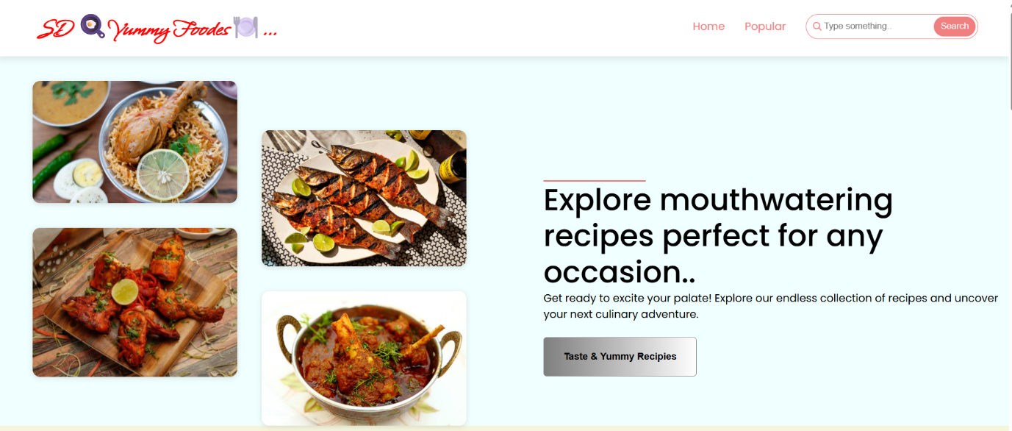

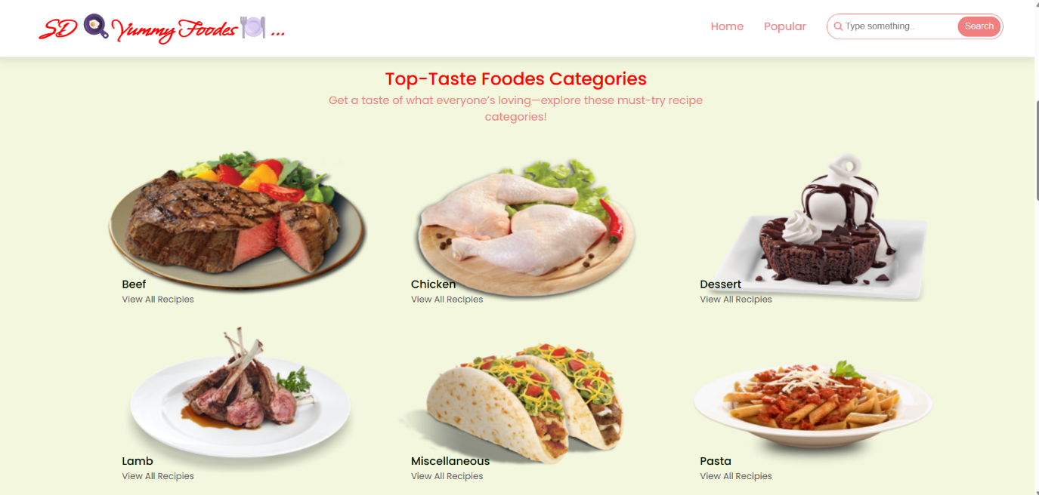

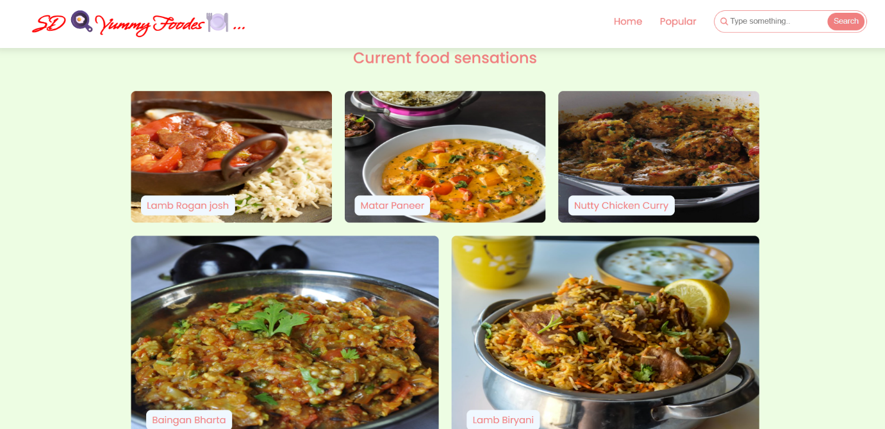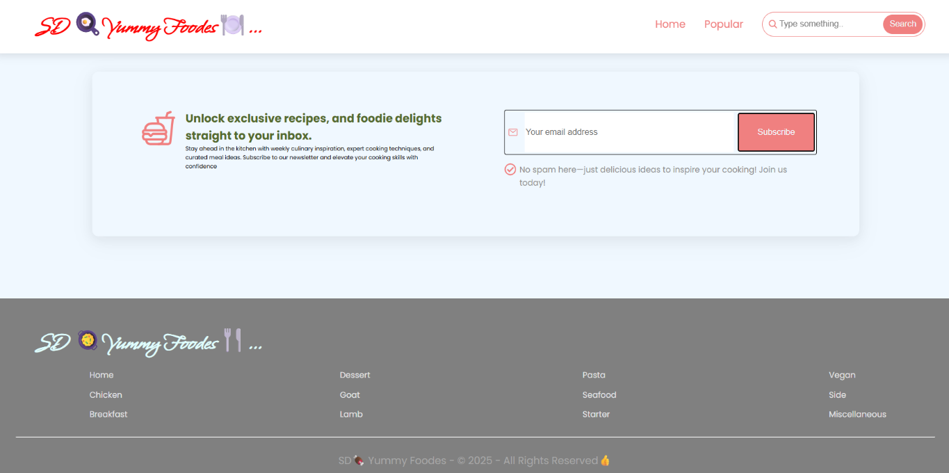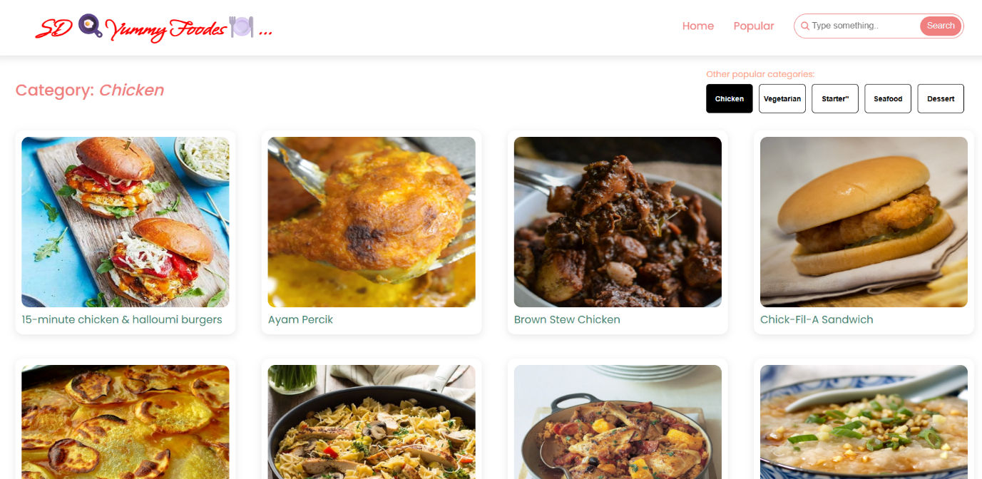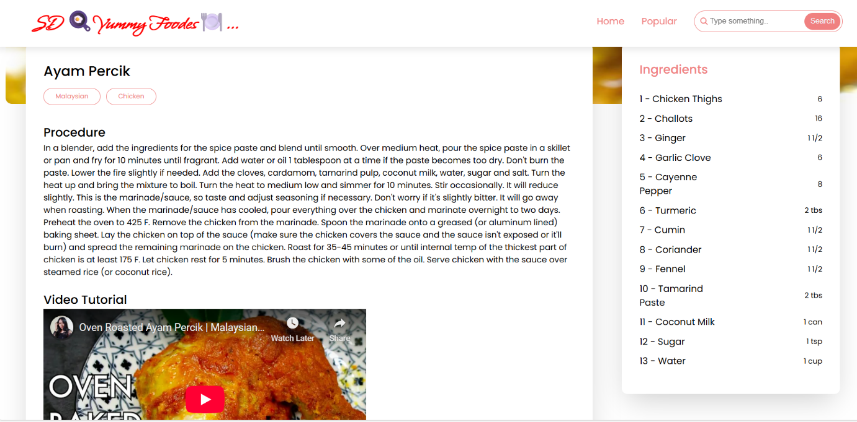

**Demo video :** **https://drive.google.com/file/d/1WfRoDaRQrOFtSKVIKcUCNYcaZsZdgfSq/view?usp=sharing**

1. **Known Issues**

* [Add if you found any limitation. ,example., no backend integration].

1. **Future Enhancements**

**Voice Interaction**

* **Add voice commands for hands-free operation while cooking.**
* **Text-to-speech for reading out recipes step-by-step.**

**Smart Search and Filtering**

* **Search by ingredient, cuisine, dietary needs, or available time.**
* **Suggest recipes based on what's in the user's fridge (pantry tracker integration).**

**Dynamic Step-by-Step Guidance**

* **Break down recipes into simple timed steps.**
* **Include timers and progress tracking.**

**AI Recipe Generator**

* **Generate new recipes based on available ingredients, dietary preferences, or cuisine type**

---------------------------------THANK YOU--------------------------------